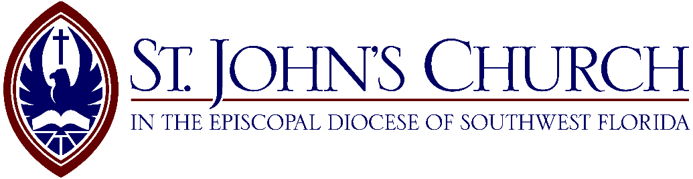
The Eleventh Sunday
after Pentecost
Proper 16

Holy Eucharist Rite II – 9:30 a.m.
August 24, 2025

Sunday Services
8:00 Holy Eucharist Rite I
9:30 Holy Eucharist Rite II

Be thoughtful, be silent, be reverent, for this is the house of God.
Before the service speak to the Lord; during the service let the Lord speak to you;
after the service speak to one another.

The Rector’s Welcome

Happy new academic year! The hustle and bustle of this thriving parish is upon us again! The children are back in school, singing like little angels. The Choir has returned from a well-deserved break, and we are ready to put the pedal to the metal to make Jesus Christ known, worshipped, and adored here in Tampa!

Children’s Chapel has returned, and Sunday School will return soon on Sunday mornings. Look out for some incredible once-per-month Wednesday night activities this year as we gear up for some of the most fun this parish has ever had.

All are invited to join us in these various ministries, and all visitors are especially encouraged to join Saint John’s and be welcomed into this incredible parish and day school. Nothing makes us happier here at Saint John’s than welcoming visitors and new members. If you are looking for a church home, look no further; you have found your home! Please make yourself known at the welcome table in the courtyard so we can get to know you better. We aspire to be a blessing to all who come through this church's doors, and we pray that the Holy Spirit continues to guide us in greeting you and making you feel welcome.

On top of all that, we are back in the Church! Our time in the wilderness, otherwise known as the Parish Hall, has come to an end, and we can all take in the marvelous nave and sanctuary of the church once again. We have restored much of this sacred space with only the bell tower remaining. I personally give thanks to God for all of you who have made this possible, from the volunteers to the Vestry to all those who gave so generously to make this all a reality. But what we must always remember is to God be the glory. Thanks be to God, and God bless us all.

Faithfully,

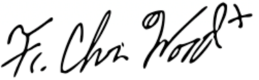
The Rev. Christian M. Wood
Rector

The people stand as the ministers enter
Processional Hymn 368 Regent Square
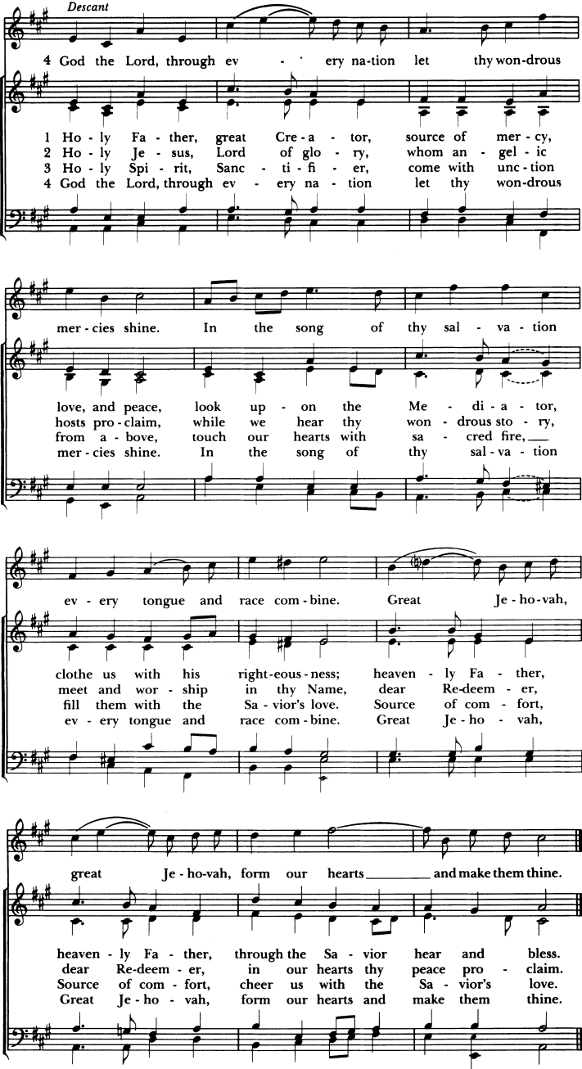
Proper Acclamation
Celebrant

People

The Collect for Purity
Celebrant
Almighty God, to you all hearts are open, all desires known, and from you no secrets are hid: Cleanse the thoughts of our hearts by the inspiration of your Holy Spirit, that we may perfectly love you, and worthily magnify your holy Name; through Christ our Lord. Amen.

Hymn of Praise 421 Allein Gott in der Höh

The Collect of the Day
Celebrant The Lord be with you.
People And also with you.
Celebrant Let us pray.
Grant, O merciful God, that your Church, being gathered together in unity by your Holy Spirit, may show forth your power among all peoples, to the glory of your Name; through Jesus Christ our Lord, who lives and reigns with you and the Holy Spirit, one God, for ever and ever. Amen.
The people sit

The Lesson Isaiah 58:9b-14
Lector A reading from the Book of the Prophet Isaiah.
“If you take away from the midst of you the yoke, the pointing of the finger, and speaking wickedness, if you pour yourself out for the hungry and satisfy the desire of the afflicted, then shall your light rise in the darkness and your gloom be as the noonday. And the Lord will guide you continually, and satisfy your desire with good things, and make your bones strong; and you shall be like a watered garden, like a spring of water, whose waters fail not. And your ancient ruins shall be rebuilt; you shall raise up the foundations of many generations; you shall be called the repairer of the breach, the restorer of streets to dwell in. “If you turn back your foot from the sabbath, from doing your pleasure on my holy day, and call the sabbath a delight and the holy day of the Lord honorable; if you honor it, not going your own ways, or seeking your own pleasure, or talking idly; then you shall take delight in the Lord, and I will make you ride upon the heights of the earth; I will feed you with the heritage of Jacob your father, for the mouth of the Lord has spoken.”
Lector The Word of the Lord.
People Thanks be to God.

Gradual: Psalm 103: 1-8 John Camidge
Sung by the choir
Praise the Lord, O my soul*
and all that is within me praise his holy Name.
Praise the Lord, O my soul*
and forget not all his benefits;
Who forgiveth all thy sin*
and healeth all thine infirmities;
Who saveth thy life from destruction*
and crowneth thee with mercy and loving-kindness;
Who satisfieth thy mouth with good things*
making thee young and lusty as an eagle.
The Lord executeth righteousness and judgement*
for all them that are oppressed with wrong.
He shewed his ways unto Moses*
his works unto the children of Israel.
The Lord is full of compassion and mercy*
long-suffering, and of great goodness.
Glory be to the Father, and to the Son, *
and to the Holy Ghost;
As it was in the beginning, is now, and ever shall be, *
world without end. Amen.

The Epistle Hebrews 12:18-29
Lector A reading from the letter to the Hebrews.
You have not come to what may be touched, a blazing fire, and darkness, and gloom, and a tempest, and the sound of a trumpet, and a voice whose words made the hearers entreat that no further messages be spoken to them. For they could not endure the order that was given, “If even a beast touches the mountain, it shall be stoned.” Indeed, so terrifying was the sight that Moses said, “I tremble with fear.” But you have come to Mount Zion and to the city of the living God, the heavenly Jerusalem, and to innumerable angels in festal gathering, and to the assembly of the first-born who are enrolled in heaven, and to a judge who is God of all, and to the spirits of just men made perfect, and to Jesus, the mediator of a new covenant, and to the sprinkled blood that speaks more graciously than the blood of Abel. See that you do not refuse him who is speaking. For if they did not escape when they refused him who warned them on earth, much less shall we escape if we reject him who warns from heaven. His voice then shook the earth; but now he has promised, “Yet once more I will shake not only the earth but also the heaven.” This phrase, “Yet once more,” indicates the removal of what is shaken, as of what has been made, in order that what cannot be shaken may remain. Therefore let us be grateful for receiving a kingdom that cannot be shaken, and thus let us offer to God acceptable worship, with reverence and awe; for our God is a consuming fire.
Lector The Word of the Lord.
People Thanks be to God.
The people stand

Sequence Hymn 521 Chelsea Square
The Gospel Luke 13:10-17
Deacon The Holy Gospel of our Lord Jesus Christ according to Luke.
People Glory to you, Lord Christ.
Now Jesus was teaching in one of the synagogues on the sabbath. And there was a woman who had had a spirit of infirmity for eighteen years; she was bent over and could not fully straighten herself. And when Jesus saw her, he called her and said to her, “Woman, you are freed from your infirmity.” And he laid his hands upon her, and immediately she was made straight, and she praised God. But the ruler of the synagogue, indignant because Jesus had healed on the sabbath, said to the people, “There are six days on which work ought to be done; come on those days and be healed, and not on the sabbath day.” Then the Lord answered him, “You hypocrites! Does not each of you on the sabbath untie his ox or his ass from the manger, and lead it away to water it? And ought not this woman, a daughter of Abraham whom Satan bound for eighteen years, be loosed from this bond on the sabbath day?” As he said this, all his adversaries were put to shame; and all the people rejoiced at all the glorious things that were done by him.”
Deacon The Gospel of the Lord.
People Praise to you, Lord Christ.
The people sit
The Sermon Father Wood
The Nicene Creed (standing)
Celebrant and People
We believe in one God,
the Father, the Almighty,
maker of heaven and earth,
of all that is, seen and unseen.
We believe in one Lord, Jesus Christ,
the only Son of God, eternally begotten of the Father,
God from God, Light from Light,
true God from true God, begotten, not made,
of one Being with the Father.
Through him all things were made.
For us and for our salvation he came down from heaven:
by the power of the Holy Spirit he became incarnate from the
Virgin Mary, and was made man.
For our sake he was crucified under Pontius Pilate;
he suffered death and was buried.
On the third day he rose again in accordance with the Scriptures;
he ascended into heaven and is seated at the right hand
of the Father.
He will come again in glory to judge the living and the dead,
and his kingdom will have no end.
We believe in the Holy Spirit, the Lord, the giver of life,
who proceeds from the Father and the Son.
With the Father and the Son he is worshiped and glorified.
He has spoken through the Prophets.
We believe in one holy catholic and apostolic Church.
We acknowledge one baptism for the forgiveness of sins.
We look for the resurrection of the dead,
and the life of the world to come. Amen.
The Prayers of the People (Form III)
The people kneel
The Leader and People pray responsively
Father, we pray for your holy Catholic Church;
That we all may be one.

Grant that every member of the Church may truly and humbly serve you:
That your Name may be glorified by all people.
We pray for all bishops, priests, and deacons;
That they may be faithful ministers of your Word and Sacraments.
We pray for all who govern and hold authority in the nations of the world. That there may be justice and peace on the earth.
Give us grace to do your will in all that we undertake; That our works may find favor in your sight.
Have compassion on those who suffer from any grief or trouble;
That they may be delivered from their distress.
Give to the departed eternal rest.
Let light perpetual shine upon them.
We praise you for your saints who have entered into joy;
May we also come to share in your heavenly kingdom.
Let us pray for our own needs and those of others.
Additional prayers are added
The Celebrant adds this concluding collect
Almighty and eternal God, ruler of all things in heaven and earth: Mercifully accept the prayers of your people, and strengthen us to do your will; through Jesus Christ our Lord. Amen.
Confession of Sin and Absolution
Deacon Let us confess our sins against God and our neighbor.
All Most merciful God,
we confess that we have sinned against you
in thought, word, and deed, by what we have done,
and by what we have left undone.
We have not loved you with our whole heart;
we have not loved our neighbors as ourselves.
We are truly sorry and we humbly repent.
For the sake of your Son Jesus Christ, have mercy on us
and forgive us; that we may delight in your will,
and walk in your ways, to the glory of your Name. Amen.
Celebrant Almighty God have mercy on you, forgive you all your sins through our Lord Jesus Christ, strengthen you in all goodness, and by the power of the Holy Spirit keep you in eternal life. Amen.
All stand

The Peace
Celebrant The peace of the Lord be always with you.
People And also with you.

All greet one another with the sign of peace then sit for any necessary announcements
Greetings and announcements
Offertory Sentence
Offertory Anthem
I Heard the Voice of Jesus Say – Philip Stopford
I heard the voice of Jesus say, “Come unto Me and rest; Lay down, O weary one, lay down thy head upon My breast.” I came to Jesus as I was, weary, and worn, and sad; I found in him a resting-place, and he has made me glad. I heard the voice of Jesus say, “Behold, I freely give the living water; thirsty one, stoop down, and drink, and live.” I came to Jesus, and I drank of that life-giving stream; My thirst was quench'd, my soul revived, and now I live in him. I heard the voice of Jesus say, “I am this dark world’s Light; Look unto me, your morn shall rise, and all your day be bright.” I looked to Jesus, and I found in him my Star, my Sun; And in that Light of life I’ll walk, till trav'ling days are done.
All stand

Doxology 380 Stanza 3 Old 100th
Praise God, from whom all blessings flow;
praise him, all creatures here below.
Praise him above, ye heavenly host;
praise Father, Son, and Holy Ghost.

The Great Thanksgiving Eucharistic Prayer A
Celebrant The Lord be with you.
People And also with you.
Celebrant Lift up your hearts.
People We lift them to the Lord.
Celebrant Let us give thanks to the Lord our God.
People It is right to give him thanks and praise.
Celebrant It is right, and a good and joyful thing, always and everywhere to give thanks to you, Father Almighty, Creator of heaven and earth.
Here a proper preface is sung or said
Therefore we praise you, joining our voices with Angels and Archangels and with all the company of heaven, who for ever sing this hymn to proclaim the glory of your Name:
Sanctus and Benedictus S-125 Richard Proulx
The people kneel
Celebrant
Holy and gracious Father: In your infinite love you made us for yourself, and, when we had fallen into sin and become subject to evil and death, you, in your mercy, sent Jesus Christ, your only and eternal Son, to share our human nature, to live and die as one of us, to reconcile us to you, the God and Father of all. He stretched out his arms upon the cross, and offered himself, in obedience to your will, a perfect sacrifice for the whole world.
On the night he was handed over to suffering and death, our Lord Jesus Christ took bread; and when he had given thanks to you, he broke it, and gave it to his disciples, and said, "Take, eat: This is my Body, which is given for you. Do this for the remembrance of me."
After supper he took the cup of wine; and when he had given thanks, he gave it to them, and said, "Drink this, all of you: This is my Blood of the new Covenant, which is shed for you and for many for the forgiveness of sins. Whenever you drink it, do this for the remembrance of me."
Therefore we proclaim the mystery of faith:
Celebrant and People
Christ has died.
Christ is risen.
Christ will come again.
Celebrant
We celebrate the memorial of our redemption, O Father, in this sacrifice of praise and thanksgiving. Recalling his death, resurrection, and ascension, we offer you these gifts.
Sanctify them by your Holy Spirit to be for your people the Body and Blood of your Son, the holy food and drink of new and unending life in him.
Sanctify us also that we may faithfully receive this holy Sacrament, and serve you in unity, constancy, and peace; and at the last day bring us with all your saints into the joy of your eternal kingdom.
All this we ask through your Son Jesus Christ: By him, and with him, and in him, in the unity of the Holy Spirit all honor and glory is yours, Almighty Father, now and for ever. AMEN.
And now, as our Savior Christ has taught us, we are bold to say,
Celebrant and People
Our Father, who art in heaven, hallowed be thy Name, thy kingdom come, thy will be done, on earth as it is in heaven. Give us this day our daily bread. And forgive us our trespasses, as we forgive those who trespass against us. And lead us not into temptation, but deliver us from evil. For thine is the kingdom, and the power, and the glory, forever and ever. Amen.

The Breaking of the Bread
The Celebrant breaks the consecrated Bread after which the following is sung
Fraction Anthem S-171 Mason Martens

Celebrant
The Gifts of God for the People of God.


All baptized Christians are welcome to receive Holy Communion at the Lord’s Table.
If you are not receiving, you are invited to come forward for a blessing, indicated by crossing your arms over your chest. Please follow the direction of the ushers, and inform them if you need communion brought to you. Gluten-free hosts are available upon request.
Communion is offered in both kinds (bread and wine). You may receive the host only or the host by intinction. For intinction, a member of the clergy or chalice bearer will dip the host into the chalice and place it directly on your tongue. Even if receiving in one kind, please remain at the altar rail until the chalice has passed.
The Bread and the Cup are given to the communicants with these words:
The Body of Christ, the bread of heaven. Amen.
The Blood of Christ, the cup of salvation. Amen.
or with these words
The Body (Blood) of our Lord Jesus Christ keep you in everlasting life. Amen.
Communion Motet
Sing, My Soul, His Wondrous Love – Ned Rorem
Sing, my soul, his wondrous love, who, from yon bright throne above, ever watchful o'er our race, still to us extends his grace. Heaven and earth by him were made; all is by his scepter swayed; what are we that he should show so much love to us below? God, the merciful and good, bought us with the Savior's blood, and, to make salvation sure, guides us by his Spirit pure. Sing, my soul, adore his Name! Let his glory be thy theme: praise him till he calls thee home; trust his love for all to come.

Communion Hymn 315 Song 1
All stand
Post Communion Prayer
Celebrant Let us pray.
The people kneel
Celebrant and People
Eternal God, heavenly Father,
you have graciously accepted us as living members of your Son
our Savior Jesus Christ, and you have fed us with spiritual food in
the Sacrament of his Body and Blood.
Send us now into the world in peace, and grant us strength and
courage to love and serve you with gladness and
singleness of heart; through Christ our Lord. Amen.
The Blessing
The Celebrant gives the Blessing
People Amen.
The Dismissal
The Deacon gives the Dismissal
People Thanks be to God.
The people stand
Processional Hymn 411 St. Thomas (Williams)

Assisting in Today’s Services
Altar Guild: Jan Williams, Gwyn Schabacker, Chris McAdams, Debbie Tozier, Jan Kelley, Madeleine Tellekamp, Lyz Pickette, Laurie Lackman
Linens: Laurie Lacktman
Acolytes: 8:00 Greg Gaar
9:30 Paul Brokaw, Elsie Whiteley, Maggie Wood, Michael Wood, Martha Wood
Chalice: Andy Brown
Lectors: 8:00 Eric Williams, Greg Gaar
9:30 Andy Brown, Steve Straske, Drew Graham
Ushers: 8:00 Brien Burkett, Charles Harden
9:30 Keith Lindquist, Norm Allen, Cary Brown, Roger Kurz, Eric Williams, Bruce Yost
Verger: Greg Gaar Subdeacon: Eric Williams

Prayer Requests
Your prayers are bid today and throughout the week for:

All bishops and other ministers: Stephen, the Archbishop of York; Sean, our Presiding Bishop; Douglas, our Bishop; and the clergy and staff of our Parish
Those who govern: Donald, our President; Ronald, our Governor; and Jane, our Mayor
Diocesan Cycle of Prayer: Diocese of Southwest Florida and its parishes, especially St. Andrew’s, Boca Grande; St. David’s, Englewood; Church of the Good Shepherd, Punta Gorda; St. Nathaniel’s, North Port; St. James’, Port Charlotte; Good Shepherd, Venice, and St. Mark’s, Venice
Our Companion Dioceses: Dominican Republic, Georgia, South Carolina, and Western Louisiana
Anglican Cycle of Prayer: Church of the Province of South East Asia
Also remembering in prayer: Our Parish Day School, our Pastoral Care Team, healthcare workers, first responders, and all who serve the common good, peace in Ukraine and the Holy Land
Members of our armed forces deployed abroad and their families: Rich, Mike, Jake, Matthew, David, and Tyler (Libya)
Those celebrating the anniversary of their birth:
August 24: Kam Hearing, Mary Keesling, Adajean Samson, Avery Guyton, Barbara Weston, Robin Michel, Russ Shenk, Courtney Robinson, Hailey Lassacher, Phyllis Mitchell, Trey Elliott
August 25: Trey Elliott, Mark Weston, Kent Ihrig, Norman Stallings, Davis Compton, Ford Taylor, James Isaacs, Harper Shellgren
August 26: Mac McCraw, Leslie Minder, Francis Maguire, Luke Isaacs
August 27: Miller Hoskins, Dallas Coffield, Cindy Young Cox, Meghan Nelson, Edith Patenaude, Davis Farrior, Michael Maguire, Jacob Palermo, Barrett Seider
August 28: Eric Williams, Grace Shoukry, Molly Maguire
August 29: Nancy Watkins, William Few, Declan Kellar, Alex Palermo
August 30: Tina Adams, Brett Couch, Lillian Ross, Catherine Mastracci

The sick and others for whom our prayers have been especially requested: Maureen and Ken Johnston; Jackie Faircloth and family; Jeff LeVines; Pam, Shailee, and Courtney; Anna, her family and her medical team; Jayce Hicks; Carleton Compton, Richard; Michael Wood; Tor, Collin, Lee, David, Sam, Absley, Jim B., Katy, Patrick D., Ron, Yvonne, Carey, Scott, Nancy C., Joan, Lane, Juliette, Jack, Miriam, Terrie and Ric, Suzanne, Minnie, Jessica, Jackson, Will, Kenneth, Peter, Armando, Berta, Elias, Charlie, Michael, Mary, Susan, Adair, Ellie, Jim, Trevor, the Painter Family, and all those who in this transitory life, are in trouble, sorrow, need, sickness, or any other adversity

For all the faithful departed:
David Painter
Rest eternal grant unto them, O Lord; and let light perpetual shine upon them. May their souls, and the souls of all the faithful departed, through the mercy of God, rest in peace.

906 South Orleans Avenue ∙ Tampa, Florida 33606-2941
Tel. 813.259.1570 ∙ Email: parish@stjohnstampa.org
stjohnstampa.org

The Diocese of Southwest Florida
The Right Reverend Douglas Frederick Scharf
VI Bishop of Southwest Florida

The Wardens, Vestry, and Officers of the Parish

CLERGY AND STAFF

The Reverend Christian M. Wood
XVII Rector
The Reverend Andrew lazo
Associate Rector

The Reverend Caroline F. Devitt
Priest Associate for Evangelism &
Communications

The Reverend Tania M. Wilkes
Deacon
The Reverend Mary Alice Lopez
Deacon
Simon J. Morley
Organist and Director of Music
Laurie D. Lawther
Parish Administrator
Ayana S. Grady
Director of Children, Youth & Family Ministries
Janice A. De Pinto
Parish Secretary
The Reverend Donald P. Goodheart
Retired Priest in Residence
The Reverend Charles E. Connelly
Retired Priest in Residence
Hugh A. R. Jebson
Head of St. John’s School
Roderick Morris
Sexton

John H. McKay (2025)
Senior Warden
Andrew M. Brown (2025)
Junior Warden
Douglas F. Arthur
Treasurer
Elizabeth S. GRAHAM
Assistant Treasurer
Amy Yost
Clerk of the Vestry

Norman F.J. Allen III (2027)
Robert O. Alter (2026)
Roddy d. Belfatti (2025)
Cary R. Brown (2026)
C. Tweed Eckhard (2025)
Lynn L. Fluharty (2027)
Andrew B. Galavis, Sr. (2027)
Jeffrey M. Hunt (2026)
Lisa J. Leal (2026)
Christina C. McAdams (2027)

