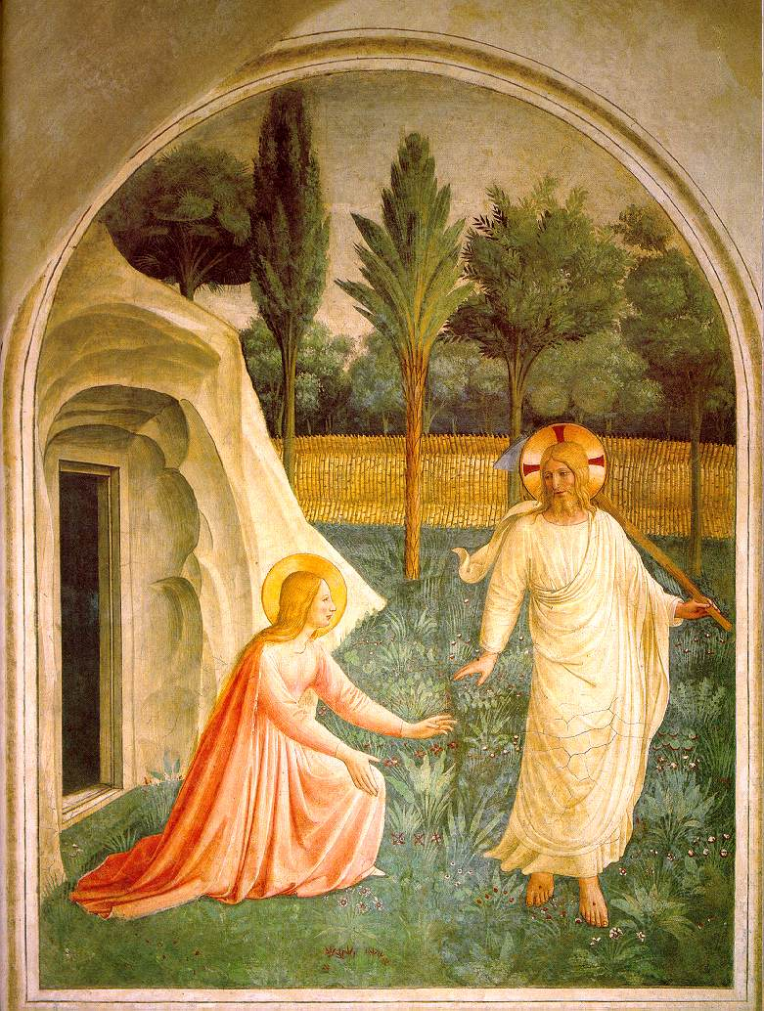
Easter Sunday
Holy Eucharist Rite II - 9:30 a.m.
March 31, 2024

Sunday Services
8:00 Holy Eucharist Rite I
9:30 Holy Eucharist Rite II

Be thoughtful, be silent, be reverent, for this is the house of God.
Before the service speak to the Lord; during the service let the Lord speak to you;
after the service speak to one another.
The Rector’s Welcome

Dear Members and Friends of Saint John’s,
Alleluia, He is Risen! Happy Easter! Did you know that Easter is not just a day but an entire season in the Church's life? The great fifty days last from Easter Day until the day of Pentecost. We mark the season of Easter with the opening acclamation at every Eucharist, “Alleluia Christ is risen.” The people respond, “The Lord is risen indeed, Alleluia!”
I hope all of us at Saint John’s take the opportunity to contemplate the risen Christ and the empty tomb this Easter season. I pray that we all focus on the hope the resurrection of Our Lord gives us and have confidence that “Jesus Christ came into the world not to condemn the world but that the world may be saved through him.” (John 3:17)
If you are visiting Saint John’s, I encourage you to join this growing and flourishing Parish Church in the heart of Tampa! Please introduce yourself to a member of the clergy after the mass today, so we can greet you and tell you more about this amazing parish.

Faithfully,
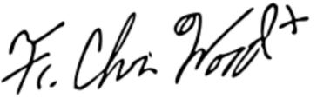
The Rev. Christian M. Wood
Rector
cwood@stjohnstampa.org

Voluntary Chorale Prelude “Gelobt sei Gott” Healey Willan
The people stand
Processional Hymn 207 Easter Hymn
Proper Acclamation
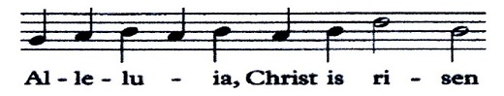
Celebrant

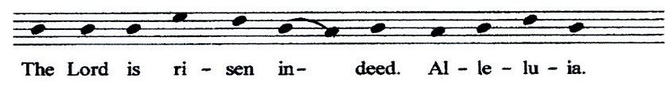
People

The Collect for Purity
Celebrant
Almighty God, to you all hearts are open, all desires known, and from you no secrets are hid: Cleanse the thoughts of our hearts by the inspiration of your Holy Spirit, that we may perfectly love you, and worthily magnify your holy Name; through Christ our Lord. Amen.
Hymn of Praise 200 Gaudeamus pariter
The Collect of the Day
Celebrant The Lord be with you.
People And also with you.
Celebrant Let us pray.
Almighty God, who through your only-begotten Son Jesus Christ overcame death and opened to us the gate of everlasting life: Grant that we, who celebrate with joy the day of the Lord's resurrection, may be raised from the death of sin by your life-giving Spirit; through Jesus Christ our Lord, who lives and reigns with you and the Holy Spirit, one God, now and for ever. Amen.
The Lesson Acts 10:34-43
The people sit
Lector A reading from the Acts of the Apostles.
Peter began to speak to Cornelius and the other Gentiles: "I truly understand that God shows no partiality, but in every nation anyone who fears him and does what is right is acceptable to him. You know the message he sent to the people of Israel, preaching peace by Jesus Christ--he is Lord of all. That message spread throughout Judea, beginning in Galilee after the baptism that John announced: how God anointed Jesus of Nazareth with the Holy Spirit and with power; how he went about doing good and healing all who were oppressed by the devil, for God was with him. We are witnesses to all that he did both in Judea and in Jerusalem. They put him to death by hanging him on a tree; but God raised him on the third day and allowed him to appear, not to all the people but to us who were chosen by God as witnesses, and who ate and drank with him after he rose from the dead. He commanded us to preach to the people and to testify that he is the one ordained by God as judge of the living and the dead. All the prophets testify about him that everyone who believes in him receives forgiveness of sins through his name."
Lector The Word of the Lord.
People Thanks be to God.
Gradual: Easter Anthems G.J. Elvey
Sung by the choir
1 Christ our passover is sacrificed for us, *
therefore let us keep the feast;
2 Not with the old leaven, *
nor with the leaven of malice and wickedness,
but with the unleavened bread of sincerity and truth.
3 Christ being raised from the dead dieth no more, *
death hath no more dominion over him.
4 For in that he died he died unto sin once; *
but in that he liveth, he liveth unto God.
5 Likewise reckon ye also yourselves to be dead indeed unto sin; *
but alive unto God through Jesus Christ our Lord.
6 Christ is risen from the dead; *
and become the first-fruits of them that slept.
7 For since by man came death, *
by man came also the resurrection of the dead.
8 For as in Adam all die; *
even so in Christ shall all be made alive.
Glory be to the Father and to the Son, and to the Holy Ghost.
as it was in the beginning is now and ever shall be, world without end. Amen.
The Epistle 1 Corinthians 15:1-11
Lector A reading from the first Letter of Paul to the Corinthians.
I would remind you, brothers and sisters, of the good news that I proclaimed to you, which you in turn received, in which also you stand, through which also you are being saved, if you hold firmly to the message that I proclaimed to you--unless you have come to believe in vain.
For I handed on to you as of first importance what I in turn had received: that Christ died for our sins in accordance with the scriptures, and that he was buried, and that he was raised on the third day in accordance with the scriptures, and that he appeared to Cephas, then to the twelve. Then he appeared to more than five hundred brothers and sisters at one time, most of whom are still alive, though some have died. Then he appeared to James, then to all the apostles.
Last of all, as to one untimely born, he appeared also to me. For I am the least of the apostles, unfit to be called an apostle, because I persecuted the church of God. But by the grace of God I am what I am, and his grace toward me has not been in vain. On the contrary, I worked harder than any of them--though it was not I, but the grace of God that is with me. Whether then it was I or they, so we proclaim and so you have come to believe.
Lector The Word of the Lord.
People Thanks be to God.
The people stand
Sequence Hymn 180 Unser Herrscher
The Gospel John 20:1-18
Deacon The Holy Gospel of our Lord Jesus Christ according to John.
People Glory to you, Lord Christ.
Early on the first day of the week, while it was still dark, Mary Magdalene came to the tomb and saw that the stone had been removed from the tomb. So she ran and went to Simon Peter and the other disciple, the one whom Jesus loved, and said to them, “They have taken the Lord out of the tomb, and we do not know where they have laid him.” Then Peter and the other disciple set out and went toward the tomb. The two were running together, but the other disciple outran Peter and reached the tomb first. He bent down to look in and saw the linen wrappings lying there, but he did not go in. Then Simon Peter came, following him, and went into the tomb. He saw the linen wrappings lying there, and the cloth that had been on Jesus’ head, not lying with the linen wrappings but rolled up in a place by itself. Then the other disciple, who reached the tomb first, also went in, and he saw and believed; for as yet they did not understand the scripture, that he must rise from the dead. Then the disciples returned to their homes. But Mary stood weeping outside the tomb. As she wept, she bent over to look into the tomb; and she saw two angels in white, sitting where the body of Jesus had been lying, one at the head and the other at the feet. They said to her, “Woman, why are you weeping?” She said to them, “They have taken away my Lord, and I do not know where they have laid him.” When she had said this, she turned around and saw Jesus standing there, but she did not know that it was Jesus. Jesus said to her, “Woman, why are you weeping? Whom are you looking for?” Supposing him to be the gardener, she said to him, “Sir, if you have carried him away, tell me where you have laid him, and I will take him away.” Jesus said to her, “Mary!” She turned and said to him in Hebrew, “Rabbouni!” (which means Teacher). Jesus said to her, “Do not hold on to me, because I have not yet ascended to the Father. But go to my brothers and say to them, ‘I am ascending to my Father and your Father, to my God and your God.’” Mary Magdalene went and announced to the disciples, “I have seen the Lord”; and she told them that he had said these things to her.
Deacon The Gospel of the Lord.
People Praise to you, Lord Christ.
The people sit
The Sermon Father Wood
The Nicene Creed (standing)
Celebrant and people
We believe in one God,
the Father, the Almighty,
maker of heaven and earth,
of all that is, seen and unseen.
We believe in one Lord, Jesus Christ,
the only Son of God, eternally begotten of the Father,
God from God, Light from Light,
true God from true God, begotten, not made,
of one Being with the Father.
Through him all things were made.
For us and for our salvation he came down from heaven:
by the power of the Holy Spirit he became incarnate from the Virgin Mary,
and was made man.
For our sake he was crucified under Pontius Pilate;
he suffered death and was buried.
On the third day he rose again in accordance with the Scriptures;
he ascended into heaven and is seated at the right hand of the Father.
He will come again in glory to judge the living and the dead,
and his kingdom will have no end.
We believe in the Holy Spirit, the Lord, the giver of life,
who proceeds from the Father and the Son.
With the Father and the Son he is worshiped and glorified.
He has spoken through the Prophets.
We believe in one holy catholic and apostolic Church.
We acknowledge one baptism for the forgiveness of sins.
We look for the resurrection of the dead, and the life of the world to come. Amen.
The Prayers of the People (Form III)
The Leader and People pray responsively
Father, we pray for your holy Catholic Church;
That we all may be one.
Grant that every member of the Church may truly and humbly serve you;
That your Name may be glorified by all people.
We pray for all bishops, priests, and deacons;
That they may be faithful ministers of your Word and Sacraments.
We pray for all who govern and hold authority in the nations of the world;
That there may be justice and peace on the earth.
Give us grace to do your will in all that we undertake;
That our works may find favor in your sight.
Have compassion on those who suffer from any grief or trouble;
That they may be delivered from their distress.
Give to the departed eternal rest.
Let light perpetual shine upon them.
We praise you for your saints who have entered into joy;
May we also come to share in your heavenly kingdom.
Let us pray for our own needs and those of others.
Silence
We pray for ______ , those in the hospital _______; those in hospice ______; for the recent faithful departed, especially ________ [and _______ in whose memory of the altar flowers are given today].
The Celebrant adds this concluding collect
Almighty and eternal God, ruler of all things in heaven and earth: Mercifully accept the prayers of your people, and strengthen us to do your will; through Jesus Christ our Lord. Amen.
Confession of Sin and Absolution
Deacon Let us confess our sins against God and our neighbor.
All Most merciful God,
we confess that we have sinned against you
in thought, word, and deed, by what we have done,
and by what we have left undone.
We have not loved you with our whole heart;
we have not loved our neighbors as ourselves.
We are truly sorry and we humbly repent.
For the sake of your Son Jesus Christ, have mercy on us
and forgive us; that we may delight in your will,
and walk in your ways, to the glory of your Name. Amen.
Celebrant Almighty God have mercy on you, forgive you all your sins through our Lord Jesus Christ, strengthen you in all goodness, and by the power of the Holy Spirit keep you in eternal life. Amen.
All stand

The Peace
Celebrant The peace of the Lord be always with you.
People And also with you.
The people sit
Greetings and announcements
Offertory Sentence
Offertory Anthems
Ye Choirs of New Jerusalem Charles Villiers Stanford
Ye choirs of new Jerusalem,
Your sweetest notes employ,
The Paschal victory to hymn
In strains of holy joy.

For Judah's Lion bursts His chains,
Crushing the serpent's head;
And cries aloud through death’s domains
To wake th'imprison'd dead.

Devouring depths of hell
Their prey at His command restore;
His ransom'd hosts pursue their way
Where Jesus goes before.
Triumphant in His glory now
To Him all power is given;
To Him in one communion bow
All saints in earth and heaven.
While we, His soldiers, praise our King,
His mercy we implore,
Within His palace bright to bring
And keep us evermore.
All glory to the Father be,
All glory to the Son,
All glory, Holy Ghost, to Thee,
While endless ages run.
Alleluia! Amen.
Christus vincit Joseph Noyon, arr. Gerre Hancock
Christus vincit, Christus regnat,
Christus imperat!
Gloria Patri, et Filio, et Spiritui Sancto. Sicut erat inprincipio, et nunc et semper,
et insaecula, saeculorum.
Christ has conquered, Christ, our sovereign,
Christ reigns for evermore!
Glory be to the Father, and to the Son, and the Holy Ghost. As it was in the beginning, is now, and for evermore, world without end. Amen.

The Great Thanksgiving Eucharistic Prayer A
Celebrant The Lord be with you.
People And also with you.
Celebrant Lift up your hearts.
People We lift them to the Lord.
Celebrant Let us give thanks to the Lord our God.
People It is right to give him thanks and praise.
Celebrant
It is right, and a good and joyful thing, always and everywhere to give thanks to you, Father Almighty, Creator of heaven and earth.
Preface of Easter
Therefore we praise you, joining our voices with Angels and Archangels and with all the company of heaven, who for ever sing this hymn to proclaim the glory of your Name:
Sanctus and Benedictus S128 William Mathias
Holy, Holy, Holy Lord, God of power and might,
heaven and earth are full of your glory.
Hosanna in the highest.
Blessed is he who comes in the name of the Lord.
Hosanna in the highest.
The people kneel
Celebrant
Holy and gracious Father: In your infinite love you made us for yourself, and, when we had fallen into sin and become subject to evil and death, you, in your mercy, sent Jesus Christ, your only and eternal Son, to share our human nature, to live and die as one of us, to reconcile us to you, the God and Father of all. He stretched out his arms upon the cross, and offered himself, in obedience to your will, a perfect sacrifice for the whole world.
On the night he was handed over to suffering and death, our Lord Jesus Christ took bread; and when he had given thanks to you, he broke it, and gave it to his disciples, and said, "Take, eat: This is my Body, which is given for you. Do this for the remembrance of me."
After supper he took the cup of wine; and when he had given thanks, he gave it to them, and said, "Drink this, all of you: This is my Blood of the new Covenant, which is shed for you and for many for the forgiveness of sins. Whenever you drink it, do this for the remembrance of me."
Therefore we proclaim the mystery of faith:
Celebrant and people
Christ has died.
Christ is risen.
Christ will come again.
Celebrant
We celebrate the memorial of our redemption, O Father, in this sacrifice of praise and thanksgiving. Recalling his death, resurrection, and ascension, we offer you these gifts.
Sanctify them by your Holy Spirit to be for your people the Body and Blood of your Son, the holy food and drink of new and unending life in him. Sanctify us also that we may faithfully receive this holy Sacrament, and serve you in unity, constancy, and peace; and at the last day bring us with all your saints into the joy of your eternal kingdom.
All this we ask through your Son Jesus Christ: By him, and with him, and in him, in the unity of the Holy Spirit all honor and glory is yours, Almighty Father, now and for ever. AMEN.
And now, as our Savior Christ has taught us, we are bold to say,
Celebrant and People
Our Father, who art in heaven, hallowed be thy Name,
thy kingdom come, thy will be done, on earth as it is in heaven.
Give us this day our daily bread.
And forgive us our trespasses,
as we forgive those who trespass against us.
And lead us not into temptation, but deliver us from evil.
For thine is the kingdom, and the power, and the glory, forever and ever. Amen.
The Breaking of the Bread
The Celebrant breaks the consecrated Bread after which the following is sung
Fraction Anthem S155 Gerald Near
Alleluia, alleluia, alleluia.
Christ our Passover is sacrificed for us;
therefore let us keep the feast.
Alleluia, alleluia, alleluia.
Celebrant The Gifts of God for the People of God.
All baptized Christians are welcome to receive Holy Communion at the Lord’s Table.
If you are not receiving, you are invited to come forward for a blessing
(indicated by crossing your arms over your chest). If you have not been baptized, and find yourself drawn to Jesus Christ and life in him, please let one of our clergy know. We would be honored to have a conversation with you about the possibility of being baptized, or any other questions.
Baptism and life in the Body of Christ is open to all.
Please fill in the kneelers at the altar during Communion from the
center aisle out, towards the side aisles.

The Bread and the Cup are given to the communicants with these words
The Body of Christ, the bread of heaven. [Amen.]
The Blood of Christ, the cup of salvation. [Amen.]
or with these words
The Body (Blood) of our Lord Jesus Christ keep you in everlasting life. [Amen.]

Communion Motets
Christ the Lord is risen arr. Geoffrey Shaw
Christ the Lord is risen! Now is the hour of darkness past; Christ hath assumed his reigning power. Behold the great accuser cast down from the skies, to rise no more: Alleluia, alleluia.
Christ the Lord is risen! ‘twas by thy blood, immortal Lamb, Thine armies trod the tempter down; ‘twas by thy word and powerful name they gained the battle and renown: Alleluia, alleluia.
Christ the Lord is risen! rejoice, ye heavens! Let ev’ry star shine with new glories round the sky! Saints, while ye sing the heav’nly war, raise your redeemer’s name on high! Alleluia, alleluia.

This joyful Eastertide arr. Charles Wood
This joyful Eastertide,
away with sin and sorrow!
My Love, the Crucified,
hath sprung to life this morrow.

Had Christ, that once was slain,
ne’er burst his three-day prison,
our faith had been in vain;
but now is Christ arisen.

Death’s flood hath lost its chill,
since Jesus crossed the river:
Lord of all life, from ill
my passing life deliver.

My flesh in hope shall rest,
and for a season slumber,
till trump from east to west
shall wake the dead in number.

Communion Hymn 193 Puer nobis
Post Communion Prayer
Celebrant Let us pray.
Celebrant and People
Eternal God, heavenly Father,
you have graciously accepted us as living members of your Son
our Savior Jesus Christ, and you have fed us with spiritual food in the
Sacrament of his Body and Blood.
Send us now into the world in peace, and grant us strength and courage to love and serve you with gladness and singleness of heart; through Christ our Lord. Amen.
The Solemn Blessing
Celebrant
The God of peace, who brought again from the dead our Lord Jesus Christ, the great Shepherd of the sheep, through the blood of the everlasting covenant, make you perfect in every good work to do his will, working in you that which is well-pleasing in his sight; and the blessing of God Almighty, the Father, the Son, and the Holy Spirit, be among you, and remain with you always. Amen.
The Dismissal
The Deacon gives the Dismissal
People Thanks be to God.
The people stand
Processional Hymn 191 Lux eoi
Voluntary Final (from Symphonie 1) Louis Vierne
Please leave the church quietly
In respect for those who choose to stay for the Voluntary.

John Bailey and Pat Ferguson in memory of Macy & Lamar Bailey, Libby Garabedian, and
Jan Ferguson.
Susan Boyd in memory of Marion & William Boyd.
Cary & Katey Brown in memory of Betsy & Michael Delea, Virginia & Dale Brown, and
Jamie Brown.
Heddy and Andy Brown in memory of Ann& Davidd Murphey and Edward Melton Brown
and in thanksgiving for Murphey Andrew Galloway.
Alvie & Lee Casey in memory of Richard Lee Casey, Jr., Alvin Casey, Charles Martin and Wilma Martin.
Canon David & Barbara Pitts in memory of Diane & John Williamson.
Janis l. Elliott in memory of the Reverend Robert J. Elliott, Frank, Pearl, George & John Elliott, Lester, Glenrose, and Pearl Ford and in thanksgiving for dear friends and St. John’s family.
Susan Lang in loving memory of Mary Alma Lang, Steve Rosser, Ann and David Murphey, John and Mary Ellen Germany, Patsy and Buddy Carte, Jim and Betty Carroll, and Jack and Sandy Murray.
Mary Alice and Victor Lopez to the Glory of God.
Trish & John McKay in memory of Joan & Howell McKay; Irene & Joe Marek and Joseph Marek.
Phyllis and Jeff Mitchell in honor of our grandson, Malcolm Andrew Mitchell
Kari Power in memory of Mark Power, Martha Bartlett, Michael Bartlett and Margaret Abenante and in thanksgiving for Thomas, Matthew and Emily Conlee.
John, Thomas and Jessie Reffue in loving memory of Mary-Teresa Reffue, Lyle and Ruth Reffue and Louis and Julia Tropia.
Pam Scruggs in memory of and thanksgiving for the life of Charles and the blessed gift of Shailee.
Pamela Shives in memory of the Reverend Bev Shives and in thanksgiving for children, grandchildren, and great grandchildren.
Mary Jane Stagi in memory of Gordon & Hazel Clark and Joseph Stagi.
Madeleine Tellekamp with gratitude for parish members who gave me encouragement in difficult times: The Rev. Deacon MaryAlice Lopez, Marci Thomas, Robert Alter, Yvonne Santiago, and M.C. and John Jenkins.
Helen Turnquist in memory of Norman Soash.

906 South Orleans Avenue ∙ Tampa, Florida 33606-2941
Tel. 813.259.1570 ∙ Email: parish@stjohnstampa.org
stjohnstampa.org

The Diocese of Southwest Florida
The Right Reverend Douglas Frederick Scharf
VI Bishop of Southwest Florida
The Wardens, Vestry, and Officers of the Parish

The Clergy and Staff

Kenton Johnston,
Shane Jeffcoat, Armando Barosa, Andres Castro
Sextons
The Reverend Christian M. Wood
XVII Rector
The Reverend Dale W. VanWormer
Associate Priest for Liturgy and Formation
The Reverend Charles E. Connelly
Retired Priest in Residence
Simon J. Morley
Organist and Director of Music
Laurie D. Lawther
Parish Administrator
Janice A. De Pinto
Parish Secretary
The Reverend John R. Peterson
Rector Emeritus
The Reverend Donald P. Goodheart
Retired Priest in Residence
The Reverend Mary Alice Lopez
Deacon
Hugh A. R. Jebson
Head of St. John’s School
Lee M. Lowry
Director of Communications
Ayana S. Grady
Director of Children, Youth & Family Ministries
Elizabeth S. Graham (2024)
Senior Warden
Andrew M. Brown (2025)
Junior Warden
Douglas F. Arthur
Treasurer
Laura . Hobby
Clerk of the Vestry

Robert O. Alter (2026)
Roddy d. Belfatti (2025)
Cary R. Brown (2026)
C. Tweed Eckhard (2025)
Donna A. Gem (2024)
John N. Giordano (2024)
Jeffrey M. Hunt (2026)
Lisa J. Leal (2026)
John H. McKay (2025)
Stephen B. Straske, II (2024)

